DIY Reversible Cat Bed Tutorial

I took this tutorial from the site: http://redthreaddiy.com/blog/2009/11/diy-reversible-pet-bed-tutorial/

However, I have made some changes from her instructions – regarding the size of the bed, the size of the tubing, and a hem issue on the tubing before you sew it. I have added those into this print-up set of instructions.

Here is what the finished product will look like:

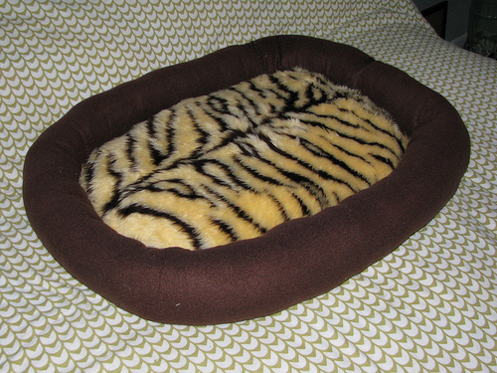

Materials:
- 1/2 yard of fabric for the first side
- 1/2 yard of fabric for the reversible side
- 1/2 yard of fabric for the walls
- LOTS of scraps of fabric, or 12 oz. of Polyester Filling
- Newspaper or other paper to make your pattern out of
- Thread
- Needle
- Sewing Machine (or you could sew it by hand, but it’d take a long time!)
- Scissors

Step 1:
Cut a rectangle out of paper that measures 20 x 16 inches.
Fold the rectangle in half, and then fold it again in half the opposite way, so that all of the corners are in one place.
Then take your scissors and round the corners. When unfolding it, you should have an even rounded pet bed pattern.

Step 2:
Pin this pattern to both the top and bottom fabric pieces, and cut them out. The top and bottom pieces can match, or can be different fabrics, depending on what you have on hand.
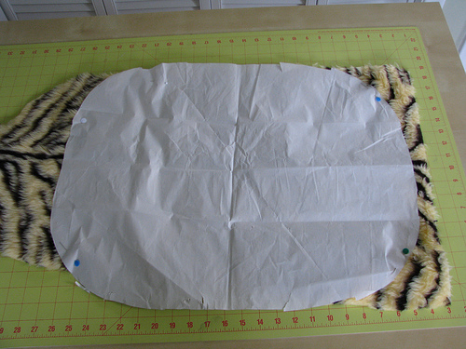
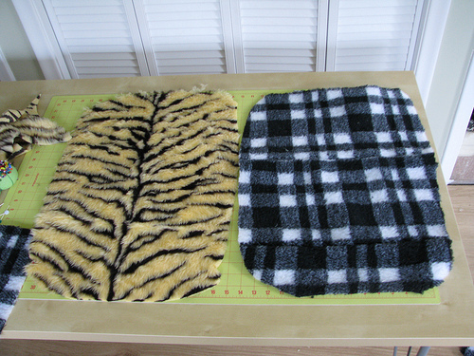
Top and Bottom Pieces Cut Out

Step 3:
Measure around the circumference of your bed. It should be approximately 58 inches around. Add an extra 8 inches for burying one end of the tube piece into the other, for a total of 66 inches. This is how long you want your tube piece to be. Now cut a long piece of fabric for the walls that is 12 inches wide by 65 inches long. You will probably have to cut two 12” pieces and sew them together to make the strip long enough. It should look something like this:
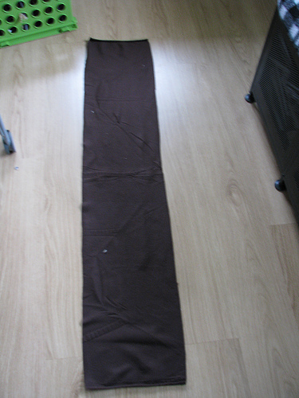

Next step: Hem ONE end of the strip, approximately ½” hem. This will be the side that stays outside, with OTHER unfinished side of the tube being buried within itself. It will make sense later if it doesn’t now, I promise!

Step 4:
Fold the strip in half, lengthwise with the right sides facing out. Right side of the fabric means that it’s the side of the fabric with the design on it. If you have a solid colored fleece like I do, it doesn’t matter either way.
Put one of your round pieces down with the right side facing up. Pin the wall all the way around the round piece.
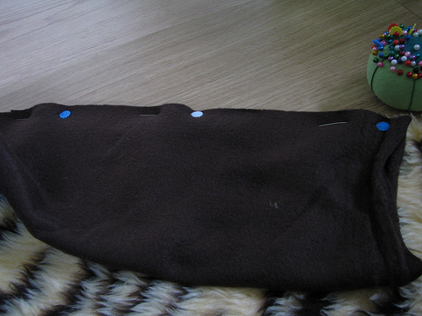
Pin the wall to a round piece
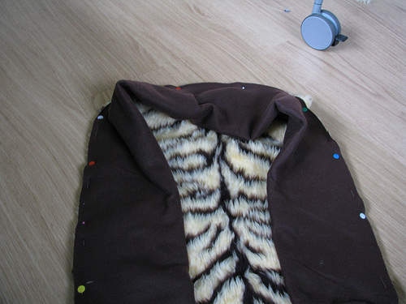
Keep pinning!
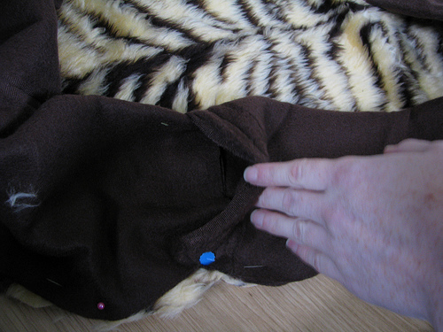
There should be a little excess to tuck the fabric in. This is where you want to make sure the unfinished edge is tucked into the hemmed (or finished) end.
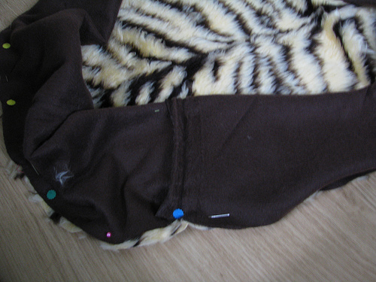
...and pin it in place!

Step 6:
Make sure that the walls are facing inward towards the center.
Add your second round piece of fabric on top of it, right side down.
Then, pin it to the other two pieces that you’ve already pinned together. Make sure that you are using the same pins and not adding any more pins. All right sides should be facing each other.
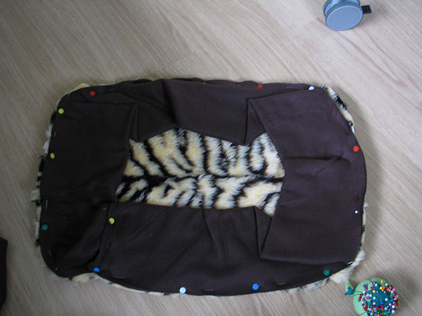
Make sure that the wall is facing in towards the center
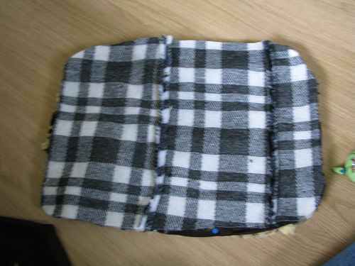
Place the second circular piece on top, with the right side facing down
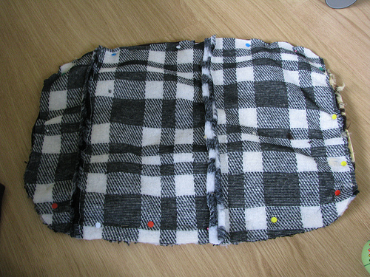
Here it is, pinned!
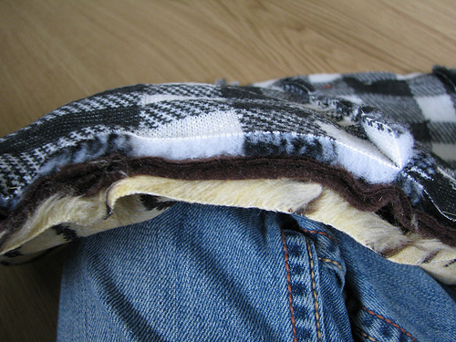
It should look like this, from the side

Step 7:
Stitch TWICE (or use a double or triple stitch setting on your machine) around the pinned edges, but MAKE SURE you leave an opening (about 3-4 inches) in order to turn all of the fabric right side out after sewing. A walking foot can make this process easier.
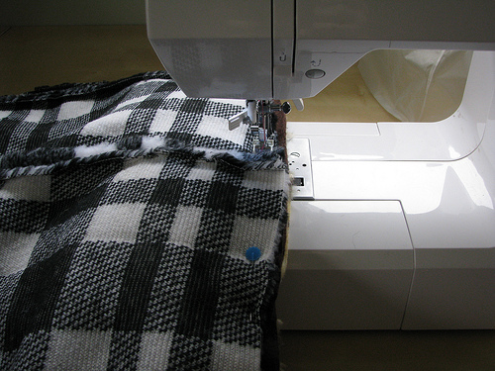
Stitch around the pinned fabric
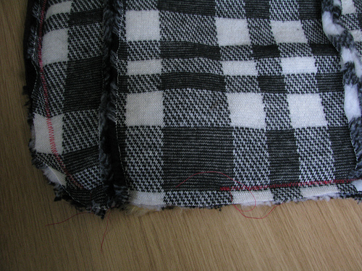
But make sure you leave enough room to flip it out!
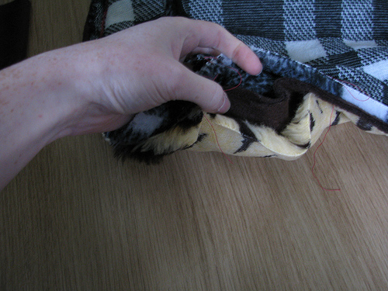
This is what the opening should look like

Step 8:
Pull the walls and everything else through the opening. At this point, you should be getting super excited. lol.
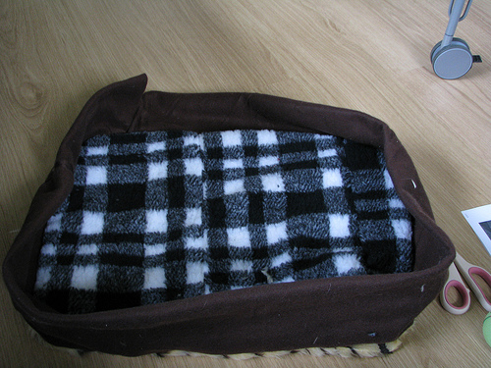
Ta-da! Side 1!
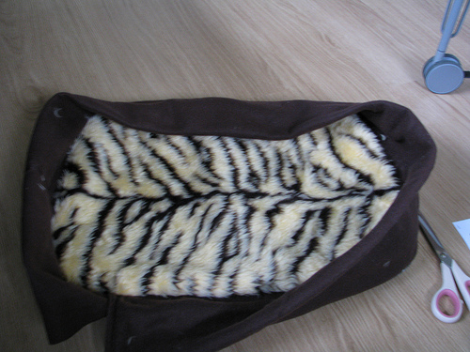
Ta-da! Side 2!

Step 9:
You can bring it to a quilt meeting and turn it into Amanda Materne, and she will stuff it. Or you can stuff it yourself with scraps or polyfil until it is nice and thick and sturdy. Then, sew the opening shut either with machine or by hand, whichever is easier for you.
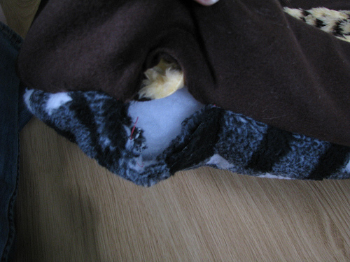
Stuff the circles!
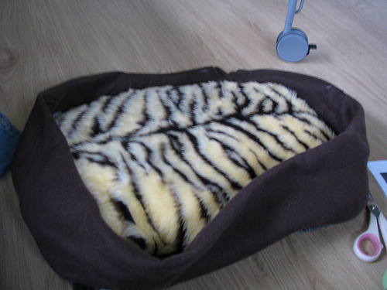
Circles are all stuffed and sealed

Step 10:
Now, stuff the walls. Push the first handfulls of fluff to the far side of the wall and work towards the opening on each half until you are satisfied with the amount of fluffiness that is in it.
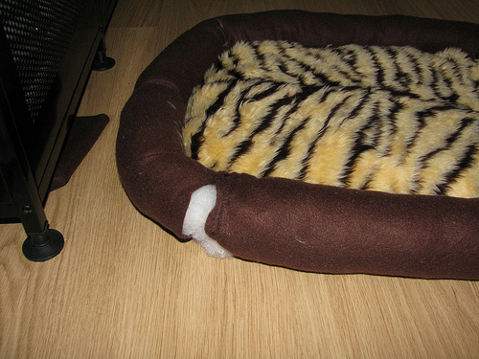
Stuff the wall

Step 11:
Stitch the wall closed by hand. I used a whip stitch.
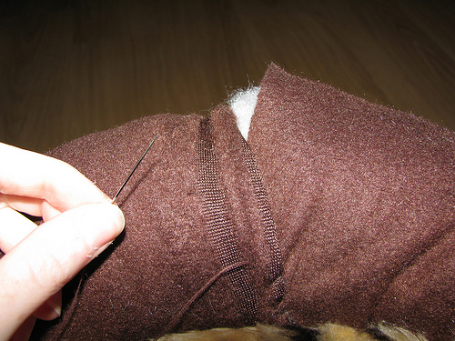
Stitch it up!

Step 12:
Finished! How awesome is it that it’s reversible and made from scraps?!
Tiger Side
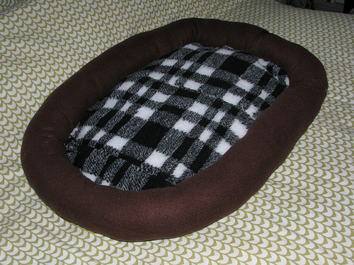
Checkered Side
Stick your pet in it, and hope that they sleep in it! Luckily, Tobor likes his He fits!
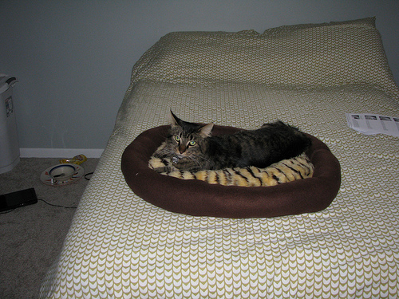
Tobor irritated that I'm photographing him while he's trying to sleep
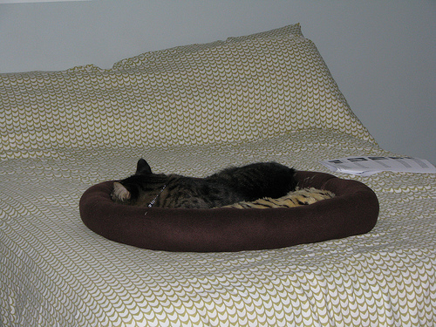
Finally getting some sleep
I hope this tutorial was easy to follow and understand. Let me know if you have any questions or comments!

